In pathfinder system, I have used Hipster Library (<http://www.hipster4j.org/>), an open source library to figure out shortest path between the two nodes. Dependent jar files are attached here too. This is eclipse project, can be executed in eclipse environment as it is.

Airport Baggage - Pathfinder

I have written a test client too, it feeds the data given in assignment into programme and provides prints output data is required format.

Figure 1: Baggage Flow Diagram

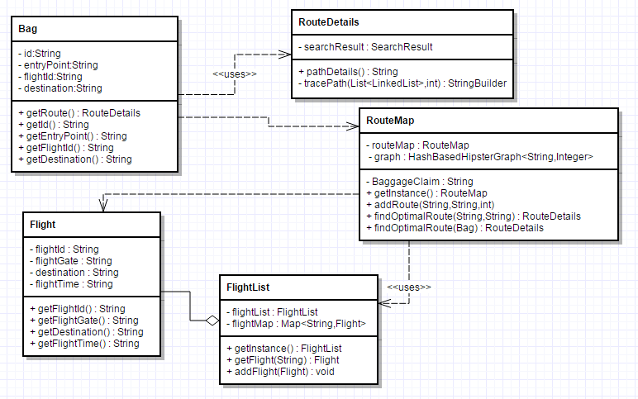

Figure 2: Class Diagram

\*\*RouteMap and FlightList are singleton class here.